

American International University-Bangladesh (AIUB)

Faculty of Science and Technology

Title of the Thesis

full name (xx-xxxxx-x)

full name (xx-xxxxx-x)

full name (xx-xxxxx-x)

full name (xx-xxxxx-x)

A Thesis submitted for the degree of Bachelor of Science (BSc) in   
Computer Science and Engineering (CSE) at   
American International University Bangladesh (AIUB  
Faculty of Science and Technology (FST)

Fall 2023-2024 Semester

Submission Date: Month, Year

# Declaration

*(All candidates to reproduce this section in their thesis verbatim)*

This thesis is composed of our original work, and contains no material previously published or written by another person except where due reference has been made in the text. We have clearly stated the contribution of others to our thesis as a whole, including statistical assistance, survey design, data analysis, significant technical procedures, professional editorial advice, financial and any other original research work used or reported in our thesis. The content of our thesis is the result of work we have carried out since the commencement of the Thesis.

We acknowledge that copyright of all material contained in my thesis resides with the copyright holder(s) of that material. Where appropriate we have obtained copyright permission from the copyright holder to reproduce material in this thesis and have sought permission from co-authors for any jointly authored works included in the thesis.

|  |  |
| --- | --- |
| _______________________________  **Name of Group Member 1**  AIUB ID  Department | _______________________________  **Name of Group Member 2**  AIUB ID  Department |
|  |  |
| _______________________________  **Name of Group Member 3**  AIUB ID  Department | _______________________________  **Name of Group Member 4**  AIUB ID  Department |

# Approval

The thesis titled **“Thesis title goes here”** has been submitted to the following respected members of the board of examiners of the department of computer science in partial fulfilment of the requirements for the degree of Bachelor of Science in Computer Science on **(date of defense)** and has been accepted as satisfactory.

|  |  |  |  |  |
| --- | --- | --- | --- | --- |
| **Name of the Supervisor**  Rank & Supervisor  Department of Computer Science  American International University-Bangladesh | |  | **Name of the External**  Rank & External  Department of Computer Science  American International University-Bangladesh | |
|  | | | | |
|  | **Dr. Akinul Islam Jony** Associate Professor & Head (UG) Department of Computer Science American International University-Bangladesh | | |  |
| **Prof. Dr. Dip Nandi**  Professor & Associate Dean  Faculty of Science and Technology  American International University-Bangladesh | |  | **Mashiour Rahman**  Sr. Associate Professor & Dean  Faculty of Science and Technology  American International University-Bangladesh | |

# Acknowledgement

Acknowledgements recognize those who have been instrumental in the completion of the project. Acknowledgements should include any professional editorial advice received including the name of the editor and a brief description of the service rendered.

# Author Contributions

List the significant and substantial inputs made by different authors to this research, work and writing represented and/or reported in the thesis. These could include significant contributions to the conception and design of the project; non-routine technical work; analysis and interpretation of research data; drafting significant parts of the work or critically revising it to contribute to the interpretation.

|  |  |  |  |  |  |
| --- | --- | --- | --- | --- | --- |
|  | **Full Name** | **Full Name** | **Full Name** | **Full Name** | **Comments** |
|  | *xx-xxxxx-x* | *xx-xxxxx-x* | *xx-xxxxx-x* | *xx-xxxxx-x* |
| **0 - 3 points** | **Perform as effective individual** | | | | |
| Critical thinking |  |  |  |  |  |
| Reflection on feedback |  |  |  |  |  |
| Quality of work |  |  |  |  |  |
| Self-directed |  |  |  |  |  |
| **0 - 3 points** | **Perform as effective team member/leader** | | | | |
| Taking responsibility |  |  |  |  |  |
| Contribution |  |  |  |  |  |
| Collaboration |  |  |  |  |  |
| Working with others |  |  |  |  |  |
| **0 - 3 points** | **Perform as effective team member/leader** | | | | |
| Presentation delivery |  |  |  |  |  |
| Voice and tone |  |  |  |  |  |
| Enthusiasm |  |  |  |  |  |
| Creativity & Tools use |  |  |  |  |  |

# Project-Thesis Planning

* Identify all the micro tasks related to project/thesis management and categorize them within the Work breakdown structure (WBS) of your thesis/project work. And describe the available resources and their allocation.

Example

Table 3: Project-Thesis Deliverables

|  |  |  |
| --- | --- | --- |
| **Project Tasks** | **Schedule Data** | **Execution Data** |
| 1. Planning | 2024.06.06 |  |
| 1. Literature Review | 2024.06.13 |  |
| 1. Survey question selection and review | 2024.06.20 |  |
| 1. Conduct survey/interview | 2024.07.18 - 2024.12.12 |  |
| 1. Writing thesis report | 2024.07.18 - 2024.12.12 |  |
| 1. Submission and review | 2024.07.18- 2024.12.12 |  |
|  |  |  |

* Prepare a Gantt Chart showing the scheduled tasks and its duration, starting and end time of each time. Well planned project and activities are in order according to chronology. Execution follows as planned in Gantt chart.

# Table of Content

Contents

Declaration ii

Approval iii

Acknowledgement iv

Author Contributions v

Project-Thesis Planning vi

Table of Content vii

List of Figures viii

List of Tables ix

List of Abbreviations x

Abstract xi

Keywords xi

Chapter 1 12

Introduction 12

1.1 Background Analys 12

1.2 Existing Studies 12

1.3 Research Motivation and Objective 12

1.4 Research Contribution 13

Chapter 2 14

Research Methodology 14

2.1 Conceptual Framework 14

2.2 Data Collection 14

2.3 Ethical Issues 15

2.4 Economic Decision 15

Chapter 3 16

Results and Analysis 16

3.1 Results and Analysis 16

3.2 Accuracy and Verification 16

3.3 Impact Analysis 16

Conclusion 17

References 18

Appendix 19

# List of Figures

|  |  |  |
| --- | --- | --- |
| Figure 1: | AMERICAN INTERNATIONAL UNIVERSITY – BANGLADESH | 18 |
|  |  |  |

# List of Tables

|  |  |  |
| --- | --- | --- |
| Table 1: | List of data | 18 |
|  |  |  |

# List of Abbreviations

Mention all the abbreviations and the different symbols that are used in this document.

Example:

|  |  |
| --- | --- |
| CS | Computer Science |
| CSE | Computer Science and Engineering |
| HCI | Human Computer Interaction |
| NLP | Natural Language Processing |

# Abstract

* The abstract should outline the main approach and findings of the thesis and normally must be between **300** and **500** words.
* An abstract is a summary of your entire thesis and should provide a complete overview of the thesis, including your key results and findings.
* An abstract is different to your introduction and shouldn’t be used to advertise your thesis. It should provide enough information to allow readers to understand what they’ll learn by reading the thesis.
* Your abstract should answer the following questions:

1. What did you do?
2. How did you do it?
3. Why was it worth doing?
4. What were the key results?
5. What are the implications or significance of the results?

# Keywords

Maximum 10 words; use lower case throughout, separating words/phrases with commas. For example: word, word, word, word, word, word.

# Chapter 1

# Introduction

Social media has become an integral part of modern life, facilitating global communication, information sharing, and community building. With over 4.9 billion users globally as of 2023, platforms like Facebook, Instagram, Twitter, and TikTok serve not only as tools for connection but also as mediums that shape public discourse and individual behaviors. However, the increasing prevalence of social media usage has sparked significant concern about its impact on mental health. While some users benefit from the sense of community and access to information, others experience adverse effects such as heightened anxiety, depression, and social isolation. The dual-edged nature of social media warrants a detailed investigation into its psychological implications, especially in an era dominated by technology.

# **Background Analys**

* ***Capture reader’s interest*** - Initially you need to capture the reader’s attention with a discussion of a broader theme relating to your research. To add impact draw on research, data, and quotations from international or national professional bodies, governmental organizations, or key authors on the topic of study.
* Describes what problems are facing with the context of the project/thesis and why is it necessary to invest effort to solve this problem.
* Describe what is the root cause of this problem? Why is this problem being so important to consider?
* Write the background description of the problem that helps put your project/thesis idea into the right context of a problem domain and gives everyone involved a common view.

# **Research** Question

**This study seeks to answer the following overarching research question:**

How can Machine Learning models be utilized to analyze the effects of social media usage on mental health, and what insights can be derived from these models?

Specific sub-questions include:

Which ML models (e.g., KStar, Random Forest, Random Tree, Logistic Model Trees (LMT)) perform best in predicting mental health outcomes based on social media usage patterns?

What are the most significant features (e.g., time spent, type of content, frequency of posting) influencing mental health in these models?

How does the performance of confusion matrix-based evaluations inform the selection of optimal models for this analysis?

What actionable recommendations can be derived from the ML analysis to promote healthier social media habits?

# Chapter 2

# Literature Review

Tsao CW [1] have made heart disease prediction is the process of identifying various methods which help to know, what kind of risk of developing heart attack or other diseases in future. Various factor which results in heart disease is natural, genetic, or due to improper care of an individual health. While in this developing era new technologies such as Machine Learning (ML) and artificial intelligence had come into the picture which help to predict various disease using data. Machine learning algorithms such as XG boost, logistic regression, decision tree and support vector machine and many more help to utilize various data sources such as genetic information, cholesterol information and electrocardiogram to know the likelihood of developing a heart disease. While in this paper different algorithms are applied and compared to predict the heart disease and later on results of different algorithm are validated using accuracy. The dataset consists of underlying 14 attributes which help in depicting the heart disease. Using random forest standard accuracy of approximately 82.10% was obtain.

Pluta et al. [2] examined CVD prediction using UK patient data, employing Random Forest and Support Vector Regression (SVR) with metrics such as MAE, RMSE, and NSE to validate results, showing how ML can enhance traditional CVD risk assessments.

Beyond healthcare, AI's role in optimizing industrial energy use is discussed by Choi et al. [3,4,5,6,8], highlighting ML’s ability to improve energy efficiency models. Similarly, Aniza et al. explored ML's potential in bioenergy, enhancing the prediction of biomass output. Che et al. demonstrated the effectiveness of time-series forecasting using models like ARIMA, MLP, and LSTM to predict medical expenditures. Liu and Zhang applied AI in quality control, showing significant improvements in manufacturing process stability. Across domains, these studies underscore the growing importance of AI-driven approaches in enhancing prediction accuracy, optimizing processes, and addressing complex challenges in health, energy, and industry.

Che, Z., Purushotham, S., Cho[9] explored advanced time-series forecasting methodologies to predict medication expenditures, employing a range of statistical, neural network, and ensemble approaches. The study utilized persistence models, ARIMA, Multi-Layer Perceptron (MLP), Long Short-Term Memory (LSTM), and ensemble techniques, highlighting the potential of neural networks, particularly LSTMs, to achieve superior forecasting accuracy. The dataset, consisting of screened medication records, provided a foundation for validating these models. However, the study identified limitations, notably the exclusion of Convolutional Neural Networks (CNNs) and other Recurrent Neural Network (RNN) models, which could enhance capabilities in predicting disease risks and diagnosing patient symptoms.

Gialluisi, A., Di Castelnuovo, A., Costanzo et al. [10] focused on the application of artificial intelligence for predicting biological age (BA) using clinical biomarkers. The models employed included linear regression, Support Vector Regression (SVR), Deep Neural Network (DNN) regression, and Random Forest (RF) regression, among others. This research demonstrated the superiority of AI-driven techniques over traditional statistical methods in estimating BA, with a notable innovation being the utilization of Permutation Feature Importance (PFI) scores to assess the contribution of biomarkers to prediction accuracy. Despite its contributions, the study highlighted a gap in the application of more sophisticated nonlinear models, which could potentially enhance the accuracy of BA predictions.

# Chapter 3

# Research Methodology

# **Conceptual Framework**

* Design project/thesis includes all possible content/information that shows good understanding of Life cycle analysis of your project/thesis.
* Select and explain appropriate conceptual model for your research in thesis (e.g., Design Science Research Methodology – DSRM). Provide some arguments for selecting your conceptual model.

# 3.2Data Collection

**Overview**

For the research study titled "An investigation on how social media affects mental health," a mixed-methods approach was employed, primarily utilizing surveys for quantitative data collection, complemented by qualitative insights from open-ended survey questions. This methodology is highly appropriate for the project's objectives, as it allows for a comprehensive understanding of the relationship between social media usage and mental health.

**Data Collection Tools**

1. **Google Forms Survey**
   * A structured survey was created using Google Forms, which included a series of closed-ended and open-ended questions designed to gather demographic information, social media usage patterns, and perceptions of mental health impacts.
   * The survey was distributed online, allowing for easy access and participation from a diverse population.

**Data Analysis Method**

1. **Quantitative Analysis**
   * The quantitative data collected through the survey will be analyzed using statistical software (e.g., SPSS, R) to perform descriptive statistics and inferential analysis. This will help identify trends, correlations, and potential causal relationships between social media usage and mental health outcomes.
   * For example, the analysis could include calculating the mean hours spent on social media and correlating this with self-reported mental health impacts.
2. **Qualitative Analysis**
   * Responses from open-ended questions will be analyzed using thematic analysis. This involves coding the responses to identify recurring themes related to emotional support, feelings of pressure, and experiences of cyberbullying.
   * A coding framework will be developed to categorize responses, making it easier to draw conclusions about the qualitative data.

**Justification for Selected Methods**

1. **Relevance to Research Questions**
   * The survey method directly addresses the research questions regarding the effects of social media on mental health by capturing both quantitative data (e.g., hours spent on social media) and qualitative insights (e.g., feelings of anxiety or pressure).
   * Surveys are well-suited for gathering data from a large population, which enhances the generalizability of the findings.
2. **Advantages Over Other Methods**
   * **Interviews**: While interviews could provide in-depth insights, they are time-consuming and may limit the number of participants due to logistical constraints. Surveys allow for the collection of data from a larger and more diverse sample, which is crucial for this research.
3. **Efficiency and Accessibility**
   * Utilizing an online survey tool like Google Forms enables easy distribution and collection of responses, making it accessible to participants across various demographics. This is particularly important given the focus on social media users, who are likely to be comfortable with online platforms.

**For Survey:**

1. Generating survey questions requires a clear understanding of the survey’s purpose and target audience. First, define the objectives, such as gathering customer feedback or evaluating employee satisfaction. Identify key topics and choose appropriate question types, like closed-ended questions for quantitative data or open-ended for qualitative insights. Use simple, direct language to ensure clarity, avoiding jargon or leading questions. Balance the survey’s length to maintain engagement while gathering sufficient data. Conduct a pilot test to identify issues and refine questions based on feedback. This process ensures the survey is focused, effective, and capable of collecting meaningful, actionable insights. What are the questions you’ve asked in interview/survey?
2. Conducting a survey involves several key steps to ensure effective data collection. First, clearly define the survey’s objectives and identify the target audience. Design the survey with well-structured, relevant questions that align with the purpose, using formats like online forms, phone interviews, or paper questionnaires. Distribute the survey through appropriate channels such as email, social media, or in-person, providing clear instructions and setting a deadline for responses. Monitor participation and send reminders if needed to ensure an adequate response rate. Once responses are collected, analyze the data to identify trends and compile a report with actionable insights.Who are respondents to answer your questions?
3. The total number of respondents depends on the survey's objectives and scope. Respondents are typically selected using methods such as **random sampling** for broad representativeness or **convenience sampling** for quick and easy access to participants. In some cases, **stratified sampling** is used to ensure representation across specific groups (e.g., age, department, or location). Participants may be invited via email, social media, or direct outreach to ensure a diverse and relevant sample.
4. Data analysis involves processing the collected responses to identify trends and patterns. Quantitative data is analyzed using statistical methods, such as calculating percentages, averages, or correlations. Qualitative data from open-ended responses is reviewed and categorized into key themes or insights. Findings are then summarized and presented using visual aids like charts, graphs, and tables, making it easier to communicate key insights. A final report highlights major trends, conclusions, and actionable recommendations based on the data analysis.

# Ethical Issues

# In conducting this research, several ethical issues were identified and addressed. First, potential bias in respondent selection was mitigated by employing stratified sampling techniques to ensure diverse representation across demographics, thereby enhancing the study's validity. Second, participant privacy was safeguarded through anonymization of data and strict adherence to data protection regulations, ensuring that personal information remained confidential and secure. Third, to maintain data integrity, all collected information was cross-verified and validated against established sources, preventing any misconduct such as falsification or plagiarism. Regular audits were conducted to ensure adherence to ethical standards, and all findings were transparently reported. Additionally, informed consent was obtained from all participants, outlining their rights and the purpose of the research. By implementing these measures, the research maintained high ethical standards while contributing valuable insights into the relationship between social media usage and mental health.

# Chapter 4

# Results and Analysis

# 4.1Results and Analysis

# Results and Analysis

Although each of the three research methods—systematic literature reviews (SLR), interviews, and surveys—has advantages and disadvantages of its own, surveys are the best way to examine how social media affects mental health.

SLR entails combining previous studies to find trends, patterns, and gaps. Although it offers a thorough theoretical framework, it is dependent on secondary data and is unable to get contextually specific, real-time insights from the target audience.

In-depth qualitative data from interviews enables a thorough examination of each person's unique experiences. However, they take a lot of time, have a reduced scope because of the smaller sample sizes, and can add bias from participant responses or interviewer influence.

On the other hand, surveys balance specificity with breadth. By gathering numerical information from a sizable, heterogeneous group of respondents, surveys offer statistically meaningful information about social media usage trends and how they relate to mental health. They encourage candid input, particularly on delicate subjects like mental health, and are effective, economical, and enable anonymised responses.

Surveys are the most effective approach for this study because they provide actionable data to efficiently address the research objectives and suggest solutions by directly capturing the behavior, experiences, and attitudes of the target audience.

Because it combines the advantages of quantitative data collecting with sophisticated analytical skills, the integration of surveys and Weka tools is important in data-driven research. Large-scale, varied datasets can be directly gathered from participants through surveys, offering practical insights on attitudes and behaviors like how social media affects mental health. Weka improves on this by using machine learning algorithms to find trends, categorize results, and uncover patterns in the dataset. This combination guarantees a thorough analysis, turning unprocessed survey data into knowledge that can be put to use. This is essential for confirming the goals of the study and putting forward workable, evidence-based solution.  
According to the poll results, bad experiences like cyberbullying are closely associated with high follower counts and excessive social media usage. Younger people are most impacted, especially those between the ages of 17 and 29, who use platforms more regularly. This suggests that interventions that are specifically designed to lessen exposure to negative online behaviors while promoting a healthier digital environment are desperately needed.  
I suggest a Personalized Digital Wellness Assistant (PDWA), an AI-powered program that is integrated into social media platforms to address this real-world issue. It encourages positive online conduct and protects mental health. The remedy consists of Behavioral monitoring keeps tabs on social media usage trends (such as hours spent and interactions with content) and notifies users when they surpass acceptable limits.

# Accuracy and Verification

Overview of the Model:

The Weka classifier, weka.classifiers.rules, was used to construct the Decision Table model.Feature selection (Best First search) is enabled in the DecisionTable. 10-fold cross-validation was the test mode employed, guaranteeing the model's evaluation's resilience.

#Decisssion Tree

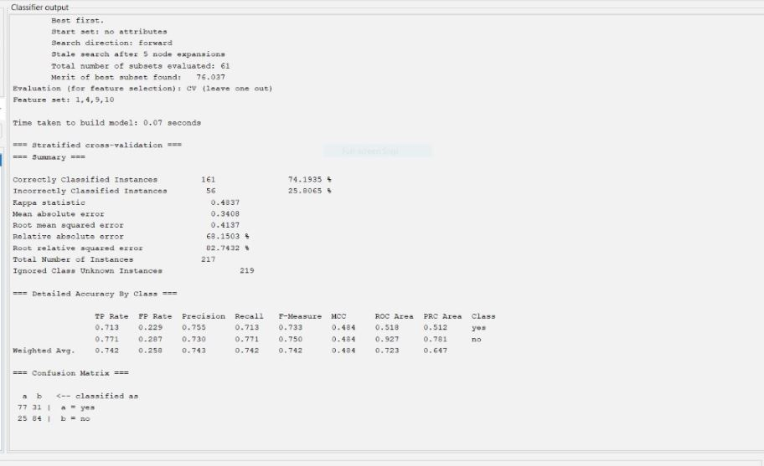

Decisssion Tree

The attached image displays the classifier evaluation results for a model trained using a decision tree with feature selection. Important points to note are:

Out of 217 occurrences, 161 (74.1935%) were correctly classified, whereas 56 (25.8065%) were wrongly classified.The model predictions and actual results show a moderate degree of agreement, as indicated by the kappa statistic of 0.4874.A mean absolute error of 0.4307, a root mean squared error of 0.4131, and a relative absolute error of 62.1503% are important error metrics.

Confusion matrix:

|  |  |  |
| --- | --- | --- |
| Classifie as | Yes(a) | No(b) |
| Actual Yes(a) | 77 | 25 |
| Actual No(b) | 84 | 31 |

#KStar

This output shows the evaluation metrics of a KStar classification model built using Weka. Let's break down the results:

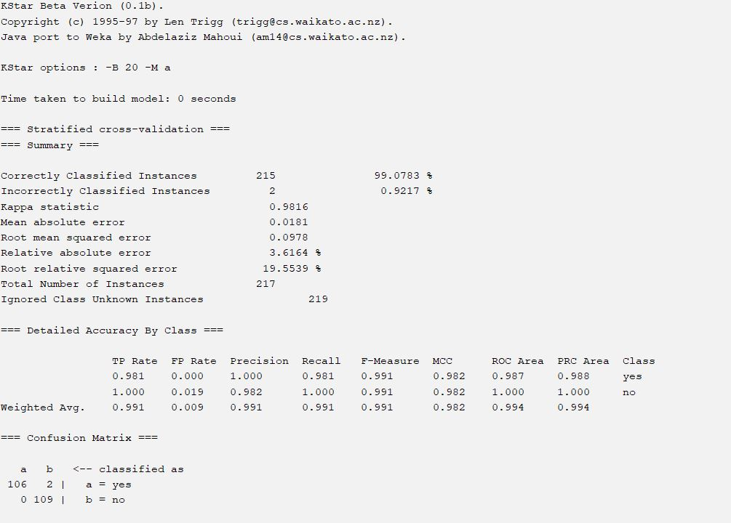

This output shows the evaluation metrics of a KStar classification model built using Weka. Let's break down the results:

The KStar classification model's output is displayed in the submitted image. The following are important details:

Just two (0.92%) of the 217 cases were misclassified, while 215 (99.08%) were correctly classified.

With a kappa statistic of 0.9816, the model demonstrated a high degree of agreement between predictions and actual results.

The mean absolute error and the root mean squared error are also extremely low at 0.0181 and 0.0978, respectively.

High classification performance is demonstrated by the weighted average F-measure of 0.991 and the overall ROC Area of 0.994.

Strong performance in both classes, with few misclassifications, is shown by the confusion matrix.

Confusion Matrix

|  |  |  |
| --- | --- | --- |
| Classifie as | Yes(a) | No(b) |
| Actual Yes(a) | 106 | 2 |
| Actual No(b) | 0 | 109 |

#LMT

Here's a summary of the provided machine learning model evaluation metrics:

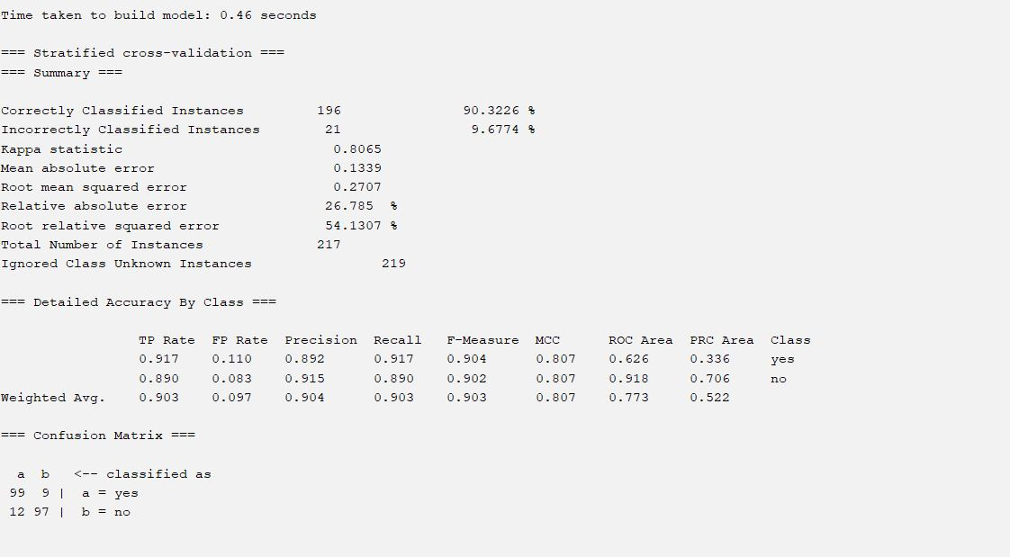LMT

21 (9.68%) of the 217 cases were misclassified, whilst 196 (90.32%) were correctly classified.

With a kappa statistic of 0.8065, the model demonstrated a high degree of agreement between predictions and results.

With a mean absolute error of 0.1339 and a root mean squared error of 0.2707, the error metrics are minimal.

Good classification performance is indicated by the weighted average F-measure of 0.903 and the overall ROC area of 0.773.

Confusion Matrix

|  |  |  |
| --- | --- | --- |
| Classifie as | Yes(a) | No(b) |
| Actual Yes(a) | 99 | 9 |
| Actual No(b) | 12 | 97 |

Random Forest

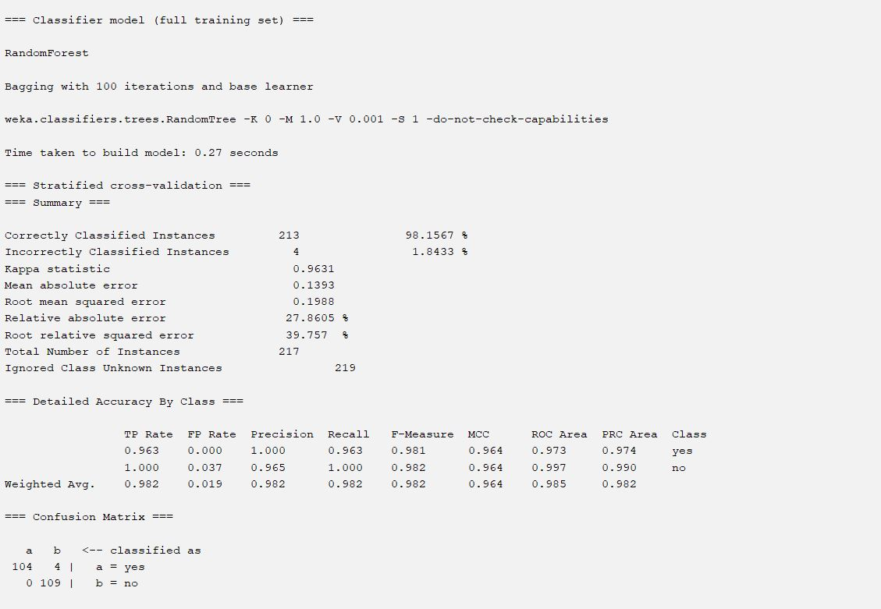

Random Forest

The model is a RandomTree base learner and a RandomForest classifier with 100 iterations. The accuracy on a stratified cross-validation test set was 98.15%, and it was constructed in 0.27 seconds. The model accurately categorized 104 out of 108 positive instances (yes) and 109 out of 109 negative instances (no), according to the confusion matrix. Overall, the performance is good, with low error rates and great precision.

Confusion Matrix

|  |  |  |
| --- | --- | --- |
| Classifie as | Yes(a) | No(b) |
| Actual Yes(a) | 104 | 4 |
| Actual No(b) | 0 | 109 |

Random Tree

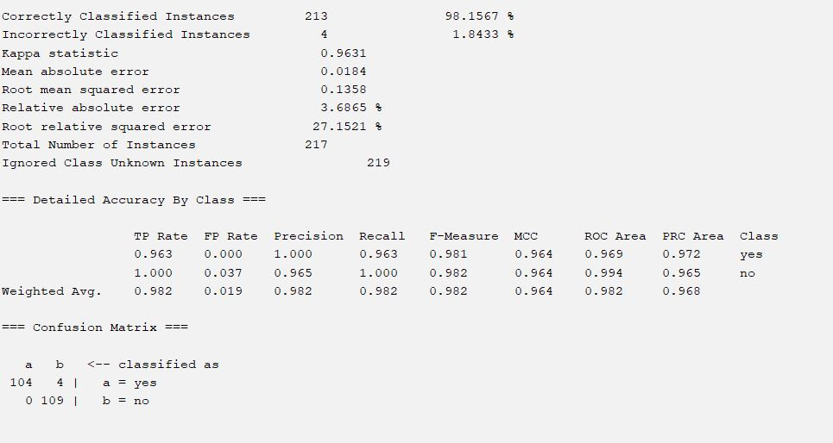

The model is a RandomTree base learner and a RandomForest classifier with 100 iterations. The accuracy on a stratified cross-validation test set was 98.15%, and it was constructed in 0.27 seconds. The model accurately categorized 104 out of 108 positive instances (yes) and 109 out of 109 negative instances (no), according to the confusion matrix. Overall, the performance is good, with low error rates and great precision.

onfusion Matrix

|  |  |  |
| --- | --- | --- |
| Classifie as | Yes(a) | No(b) |
| Actual Yes(a) | 104 | 4 |
| Actual No(b) | 0 | 109 |

#Hodde

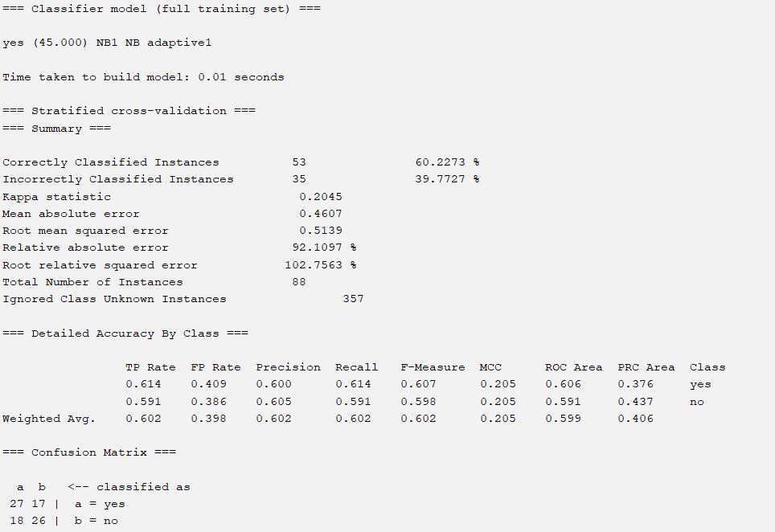

The model is an adaptive kernel-based Naive Bayes classifier. The accuracy on a stratified cross-validation test set was 60.2273%, and it was constructed in 0.01 seconds. The model accurately recognized 26 out of 35 negative examples (no) and 27 out of 53 positive instances (yes), according to the confusion matrix. With comparatively low accuracy and mistake rates, the overall performance is mediocre.

confusion Matrix

|  |  |  |
| --- | --- | --- |
| Classifie as | Yes(a) | No(b) |
| Actual Yes(a) | 27 | 17 |
| Actual No(b) | 18 | 26 |

# 

# Impact Analysis

* Social, health, safety, legal, and cultural aspects are all included in the research on the effects of social media use on mental health in computer science and engineering. Social media sites can both be resources for assistance and intervention and worsen mental health issues. Overuse of social media is associated with mental health problems, especially among vulnerable groups. Data security breaches, privacy violations, and cyberbullying are all safety concerns. Data security and the moral application of algorithms are legal concerns.Social media sites have advantages for mental health as well as disadvantages. They can promote a sense of community and give people access to resources, but they can also lead to detrimental effects on mental health, such as addiction, disinformation, and cyberbullying. A multifaceted strategy is needed for sustainable solutions, including platform regulation, mental health literacy education, digital literacy training, cooperative collaborations, and ongoing assessment. We may use social media to advance mental health by addressing stakeholder, societal, and environmental concerns.

# Chapter 5

# Discussion

# 

# Chapter 6

# Conclusion

* Restate the project/thesis objective again considering the existing problems and challenges.
* Discuss your data collection/data analysis process in providing solutions.
* Discuss the thesis/project solutions and with any significant remarks.
* Provide a description of the **limitations** of your study and how the **future researcher** can extend your study further.

# References

1. Tsao CW, Aday AW, Almarzooq ZI, Beaton AZ, Bittencourt MS, Boehme AK et al., "Heart Disease and Stroke Statistics—2022 Update: A Report From the American Heart Association", *Circulation.*, vol. 145, no. 8, pp. e153-e639, Statical analysis using machine learning algorithms 2022.
2. Statical analysis using machine learning algorithms . Pluta, K.; Por˛ebska, K.; Urbanowicz, T.; G ˛asecka, A.; Olasi ´nska-Wi´sniewska, A.; Targo ´nski, R.; Krasi ´nska, A.; Filipiak, K.J.; Jemielity, M.; Krasi ´nski, Z. Platelet–Leucocyte Aggregates as Novel Biomarkers in Cardiovascular Diseases. Biology 2022, 11, 224. [CrossRef] [PubMed] Article Early Prediction in Classification of Cardiovascular Diseases with Machine Learning, Neuro-Fuzzy and Statistical Methods
3. J.-K. Choi *et al.* Economic and environmental impacts of local utility-delivered industrial energy-efficiency rebate programs Statical analysis using machine learning algorithms, Energy Pol (2018)
4. Statical analysis using machine learning algorithms .R. Aniza *et al.*(2022) Machine learning and statistical analysis for biomass torrefaction: A review
5. Che, Z., Purushotham, S., Cho, K., Sontag, D., and Liu, Y. (2018). Recurrent neural networks for multivariate time series with missing values. Sci. Rep. 8:6085. Paper name AI in Healthcare: Time-Series Forecasting Using Statistical, Neural, and Ensemble Architectures
6. A. Smith, “Enhancing Financial Market Predictions with AI and Statistical Methods,” Journal of Financial Analytics, vol. 28, no. 3, pp. 45-58, 2023.
7. B. Johnson, C. Lee, and D. Nguyen, “Bayesian Networks for Risk Assessment and Decision Making,” International Journal of Artificial Intelligence Research, vol. 15, no. 2, pp. 101-120, 2022.
8. Y. Liu and H. Zhang, “AI-Enhanced Statistical Process Control in Manufacturing,” Manufacturing Science and Engineering, vol. 37, no. 4, pp. 235-250, 2023.
9. Z. Che, S. Purushotham, K. Cho, D. Sontag, and Y. Liu, "Recurrent Neural Networks for Multivariate Time Series with Missing Values," Scientific Reports, vol. 8, p. 6085, 2018.
10. A. Gialluisi, A. Di Castelnuovo, S. Costanzo, M. Bonaccio, M. Persichillo, S. Magnacca, et al., "Exploring Domains, Clinical Implications and Environmental Associations of a Deep Learning Marker of Biological Ageing," European Journal of Epidemiology, online ahead of print, 2021

# Appendix

* Provide any supplementary materials that you have used in your thesis such questionary of the interview and survey data collection, etc.